Video Production Syllabus (VP 1&2)

Mr. Lipsky
Room 305
Green Day, Period 4
jlipsky@dis.sc.kr
www.mrlipsky.com
2015-2016
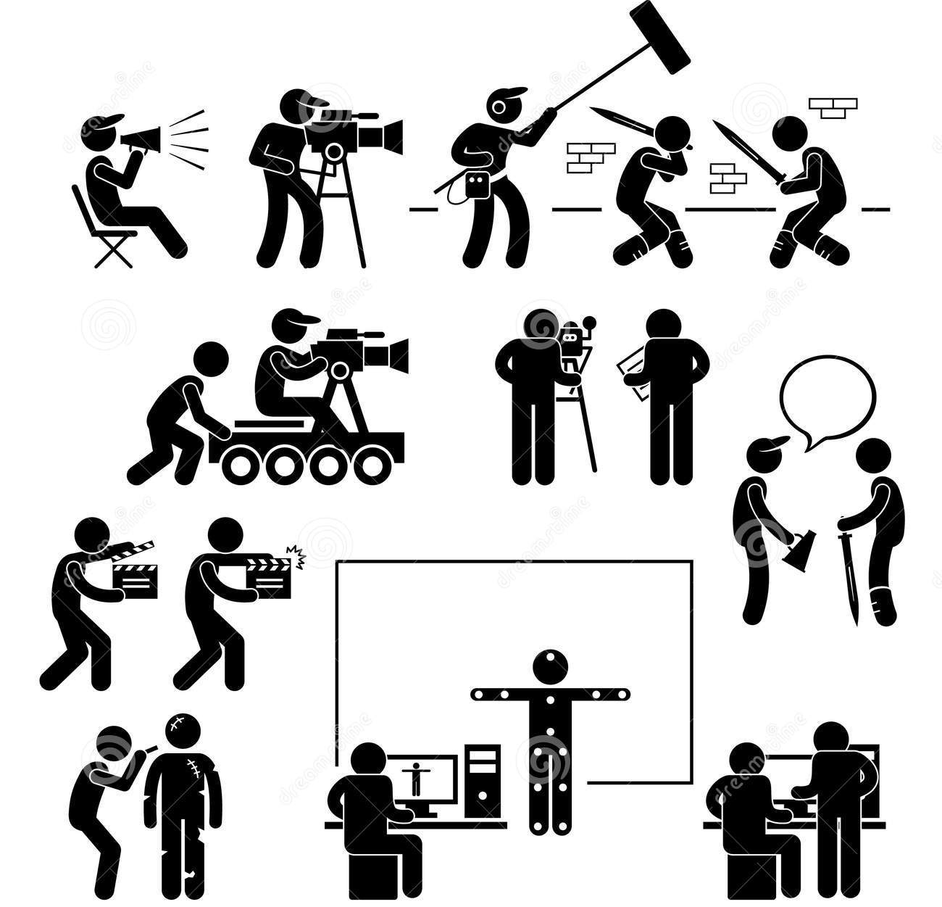

Course Materials:
There is no textbook required for this course. Students are required to save storyboards, scripts, and any other materials they create that help them design media. Please keep them in the classroom, or in a binder or folder.

Course Description:
Video Production at DIS is an elective course designed to introduce students to professional media and video production. Numerous hands-on projects will be completed throughout the year, including but not limited to: broadcast journalism, interviews, news production, music videos, commercials, promotional films, PSAs, comedies, dramas, documentaries, etc. Students will be responsible for creating school-wide media. Students will design the same quality of professional video and media that we encounter in our real lives outside of school. There will be several opportunities for authentic assessment; students will be able to go out into the field to produce media for this class. Online discussion and group collaboration will play a large role in our learning process. Students will contribute to modern pop-culture and connect the media they make to our lives here in Korea. Through media production students will become “media literate” and critically think about global communications and media trends.

Grading Policy:
20% Formative Assessments: daily work, project planning, or short projects
60% Summative Assessments: large projects, presentations, or debates
20% Participation, Attitude, & Preparation
100%

Grading Scale:

93-100 = A

85-92 = B

75-84 = C

70-74 = D

Below 70 = F

What to Bring to Class:
Students must come to each class fully prepared, and be in class on time. Points are deducted from your grade if you come to class unprepared. Students must bring personal laptop computers and laptop chargers to each class. Students are also encouraged to bring any audio or video equipment they may already own that will aid them in our media productions.

If you and your parents are by any chance making any technology purchases, students as well as professionals prefer the following items:
- Canon DSLR / SLR cameras are preferable because of the superior audio and video recording quality (or any camera with an external mic jack).
- Apple Macbooks are great for video editing.
- Adobe Creative Suite, Adobe Premiere, Sony Vegas, and Final Cut Pro X are the best for editing images and video.

Mandatory Expectations:
- Besides making videos, there is usually HW once a week of either updating the teacher on your progress, turning in storyboards, scripts, or analyzing our videos on the class forum.
- You must be a part of a minimum of 3 videos per quarter, but no maximum
  - One Jet Stream video
  - One promo video, commercial, or PSA
  - One fun video of your choice
- Zero idle time in class whatsoever. For instance if you finish filming and there are 7 minutes left, make sure to find some possible way to keep working on filming, editing, directing, etc. You are not allowed to stop making videos after 3rd video of the quarter is finished.
- You must help film a minimum of one elementary winter video during 2nd quarter. Yes this counts toward your total of 3 for that quarter.
- If you finish a 4th, 5th, etc video for the quarter you will not have to have to post on the class forums for that quarter. You will get automatic 100% on all forum posting and therefor have less homework.
- You must commit to helping film or making a video at least one time per quarter outside of designated class time. You will have advance notice of upcoming events. Finishing more than 3 videos does not count towards this and you still must do this no matter what. This is an important commitment that you should get done early each quarter.
- There is very little homework so if you miss class you must work outside of class for the equivalent of all class time missed. No previous outside of class work counts toward making it up, only the time you work after you missed the class. This work would include filming and editing one of your 3 mandatory videos. This does not include the mandatory once a month outside of class filming, that is a different grade.
- You must complete most projects within a 4-6 class period rhythm. If you miss class, you must still complete the work in the timeframe of 6 class periods, in or out of class.
- Limit all planning to only one full class period, or half and half, etc. Get the rest of your planning done outside of class, through kakao, gchat, FB, etc.
- Must bring your laptop to every single class.
- Must bring any necessary props, costumes, clothes, make-up to every single class.
- English only

Website:
www.mrlipsky.com
Besides using Powerschool for the schedule, grades, and other resources, our class is responsible for using one more important website: www.mrlipsky.com. This website will be used for checking the class agenda and for forum discussions. You will communicate with each other outside of class through the online forums. You must critically think about the media you create and discuss your work. Further details will be given in future classes.

Attendance Policy:
If a student knows about an upcoming absence, notify the teacher as far in advance as possible. If a student misses class and the absence is excused, the student is responsible for emailing the teacher as soon as possible, and coming directly to the teacher for any missing material immediately upon his / her return to school. Refer to the attendance and grading policy in the mandatory expectations above.

Come to every class and be on time. Attendance and tardiness are components of your participation grade. You can’t miss this class for any extra curricular activity, club, group, or sport unless it is an organized trip to another school for an academic or athletic competition.

Late Work Policy:
Late work will be accepted for a deduction of 10% of the total grade for each day late. After 5 days, the highest possible percentage you can earn if all answers are correct is 50%. No work, unless otherwise agreed upon or for some extenuating circumstances, will be accepted later than one week.

Late work will not be accepted for any unexcused tardy or absence.

Availability:
I am always available to help you with anything you need. My email is listed on the top of the syllabus and I check it frequently, so you can email me after school hours and get feedback. I am free and can answer your questions face-to-face before school, during my prep periods, at lunchtime, and after school.

Cheating & Plagiarism:
Let’s try not to steal random stuff from the internet.
Use royalty free audio and video.
More details will be given in class.

